Table of contents
1. Viking project should measure to ensure business value to ABC system 1
2. Reporting of planed and actual individual effort log data of K15T1_Team11 3
2.1. Week 1 3
2.2. Week 2 4

Viking project should measure to ensure business value to ABC system
No. | Measure | Why we measure? | Source | Data collection | Metrics | Description for Metric
1. | Progress | Provide the status of project | 1. Schedule  2. Project tracking spreadsheet | 1. Tasks on WBS (Schedule)  2. Tasks completed on time.  3. Tasks completed. | 1. Rate of tasks completed  = Tasks completed / Tasks on WBS  2. Rate of tasks completed on time  = Tasks completed on time / Tasks completed | Project manager can:  1. Control and monitor activities in the develop team.  2. Make a decision, prepare a new plan.
2. | Cost | Provide information about status of using funds | 1. Actual cost spreadsheet | 1. Actual cost of work performed  (ACWP) | 1. Cost variance  (CV) = BCWP -ACWP  2. Schedule variance  (SV) = BCWP - BCWS  3. Cost performance index  (CPI) = BCWP /ACWP | 1. If CV = 0, project is on budget  2. If SV = 0, project is right on schedule.  3. CPI is how much it really costs to earn the report value:  + If CPI = 1.0, we have perfect performance.  + If CPI > 1.0, we have exceptional performance.  + If CPI < 1.0, we have poor performance.  4. Help manager control cost of project. The difference between BCWP and ACWP gives manager his/her cost variance.
2. | Cost | Provide information about status of using funds | 2. Project Tracking Spreadsheet | 2. Budget cost work performed  (BCWP)
3. Budget cost work schedule
(BCWS)
3. | Customer satisfaction | 1. That is a strong predictor of customer retention, customer loyalty and product repurchase.  2. Provide the information about a customer need | 1. Customer satisfaction surveys | 1. Attribute expectations.  2. Attribute need.  3. Level of satisfaction.  4. Perception of change.  5. Likelihood to Recommend  6. Repeat Purchase Likelihood | 1. Rate of attribute expectation  2. Rate of attribute need  3. Rate of perception of change  4. Rate of satisfaction | Project manager can:  1. Know how customer satisfaction to improve in the next product.  Marketing team can:  1. Retain existing customers and add new customers  2. Help manager control requirement change
3. | Customer satisfaction |  | 2. Delivery report | 7. Number of defect reported | 1. Rate of fixed defect reported  = Number of fixed defect reported / Number of defect reported  2. Rate of function completed  3. Rate of function satisfaction customer.
 |  |  |  | 8. Number of defect reported fixed
 |  |  |  | 9. Number of function that customer think it is okay
3. | Customer satisfaction |  | 3. SRS - SDS | 10. Number of function in requirement
3. | Customer satisfaction |  | 4. Develop report | 11. Number of complete function
4. | Defect | Provide information about quality of source code | Source code review report | 1. Number of code line | 1. Rate defect / one thousand of code lines  2. % Fixed defect / number of defect  3. Average time to fix a defect | 1. Help manager know quality of source line  2. Know performance of fixing defect.
 |  |  |  | 2. Number of defect
 |  |  |  | 3. Number of fixed defect
 |  |  |  | 4. Total time to fix defect

Reporting of planed and actual individual effort log data of K15T1_Team11
References attachment: “K15T1-Team11-TA1-TeamEffortLog.xls” on Sheet “ Analysis and Conclusion”

Week 1
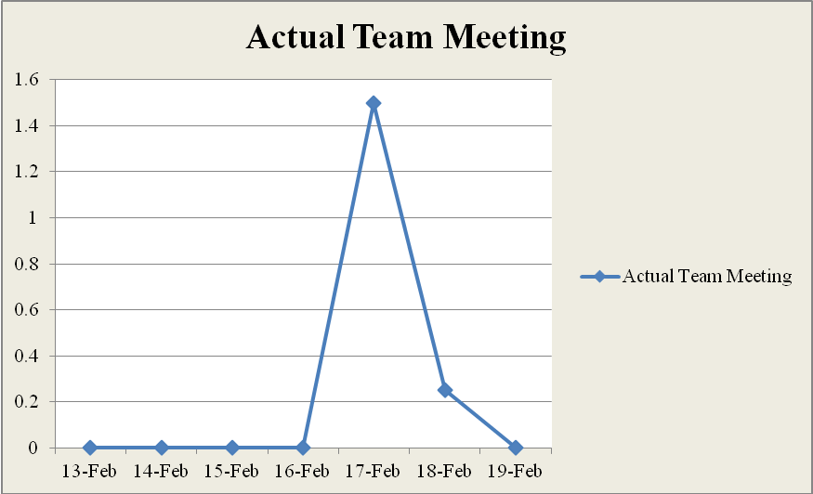
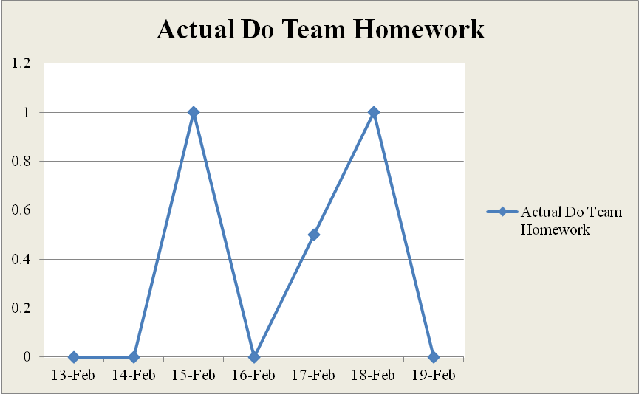

Week 2
